Review HMH Unit 1: Cells

Read each question. Circle the letter of the correct answer.

**1.** What term describes the smallest unit that can perform all of the functions necessary for life?

**A.** a single cell

**B.** a cell nucleus

**C.** a cell membrane

**D.** a multicellular organism

**2.** Robert Hooke was the first person to describe cells. Which of these instruments did he use to make his observations?

**A.** 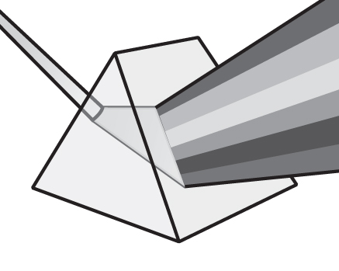

**B.** 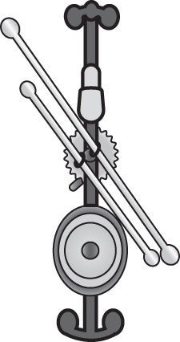

**C.** 

**D.** 

**3.** In which location does the exchange of materials in and out of a cell take place?

**A.** nucleus

**B.** chloroplast

**C.** chromosome

**D.** cell membrane

**4.** Which structure captures and stores the sun’s energy in plant cells?

**A.** chloroplast

**B.** mitochondria

**C.** Golgi apparatus

**D.** endoplasmic reticulum

**5.** All living things are made of one or more cells. Which is true of all cells?

**A.** They all have cytoplasm.

**B.** They all have DNA in their nucleus.

**C.** They all have DNA in their cytoplasm.

**D.** They all have organelles bound by membrane.

**6.** What is the main function of chloroplasts in a plant cell?

**A.** They produce proteins.

**B.** They store water and food.

**C.** They perform photosynthesis.

**D.** They protect cells from the surrounding environment.

**7.** Cells must be able to perform certain functions in order to survive. Which action must all cells do to survive?

**A.** absorb wastes

**B.** obtain energy

**C.** utilize oxygen

**D.** continue growing

**8.** What type of cell has membrane-bound organelles?

**A.** eukaryotic cells

**B.** prokaryotic cells

**C.** both prokaryotic and eukaryotic cells

**D.** neither prokaryotic nor eukaryotic cells

**9.** Which of these describes the structure of the endoplasmic reticulum?

**A.** a system of folded membranes

**B.** a tiny organelle that has no membrane

**C.** a rigid, protective layer found outside the cell membrane

**D.** an organelle surrounded by a double membrane and containing DNA

**10.** Which of the following is an accurate sentence?

**A.** Plants are unicellular organisms that have specialized functions.

**B.** All organisms are multicellular and carry out similar functions of life.

**C.** The single cell of a unicellular organism carries out all functions of life.

**D.** The single cell of a unicellular organism can have specialized functions.

**11.** What is the name of the process that allows plants to produce their own food?

**A.** glucose

**B.** chlorophyll

**C.** chloroplasts

**D.** photosynthesis

**12.** Kai is developing a multimedia presentation on multicellular organisms. Which of these will she include in her report?

**A.** yeasts

**B.** fungi

**C.** bacteria

**D.** prokaryotes

**13.** In biology class Zach observes cells. Each cell has a structure that separates the inside of the cell from the environment. Which structure is Zach observing?

**A.** the nucleus

**B.** the cytoskeleton

**C.** the cell membrane

**D.** the genetic material

**14.** Jayden knows that multicellular organisms are more complex than unicellular organisms. Which of these is a characteristic of multicellular organisms?

**A.** obtaining food

**B.** having organelles

**C.** being able to move

**D.** having specialized cells

**15.** Alice is studying prokaryotic and eukaryotic cells.

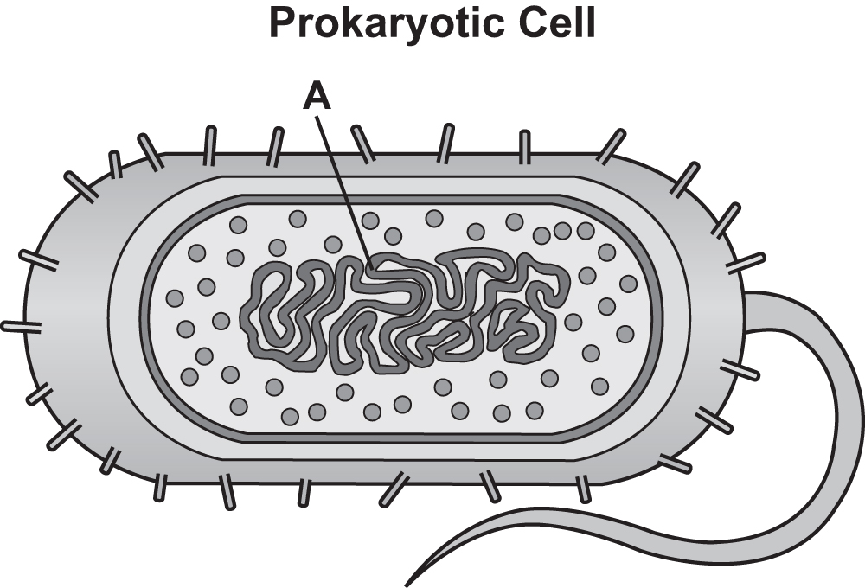

How does the part of the cell labeled *A* help Alice know that she is looking at a prokaryotic cell?

**A.** *A* is cytoplasm, which is only found in prokaryotic cells.

**B.** *A* is the cell membrane, which is only found in prokaryotic cells.

**C.** *A* is the nucleus, which is only found in prokaryotic cells.

**D.** *A* is DNA, which is not enclosed in a nucleus, as in prokaryotic cells.